Database Schema Documentation
Makayla Lewis

Table / Column Names (Data Type)
- Hourly_weather_fact: Fact table with all of the data for visuals
  - Date (date time zone): Predicted weather date/time.
    - Foreign Key
  - Uv_index (whole number): Predicted UV index.
    - Foreign Key
  - Precipitation (decimal): Predicted rain per hour
  - Temperature_2m (whole number): Predicted temperature
    - Foreign Key
  - Precipitation_probability (whole number): Precipitation chances
  - Wind_gusts_10m (whole number): Prediction of wind gust
  - Wind_speed_10m (whole number): Prediction of wind speed
  - Precipitation Add (decimal): Wind_gusts_10m + Win_speed_10m
    - Foreign Key
  - Step 1: Can I play outside (text): Calculated column to determine yes/no on outside playtime
- Id_date: Date Key
  - Datetime (date time zone): Primary Key
  - Date (date): Date of predicted weather
  - Time (time): Time of day
- Id_uv accessories: UV Index Key
  - Uv_index (whole number): Primary Key
  - Sunscreen / Hat / Sunglasses (text): Calculated column based on what the predicted UV Index will be
- Id_temp outfit type: Temperature Key
  - Temperature_2m (whole number): Primary Key
  - Outfit Type (text): Calculated column based on what the predicted temperature will be
- Id_precipitation: Precipitation Key
  - Precipitation key (whole number): Primary Key
  - Rain Jacket / Rainboots (text): Calculated column based on precipitation chance and rain per hour
Relationships
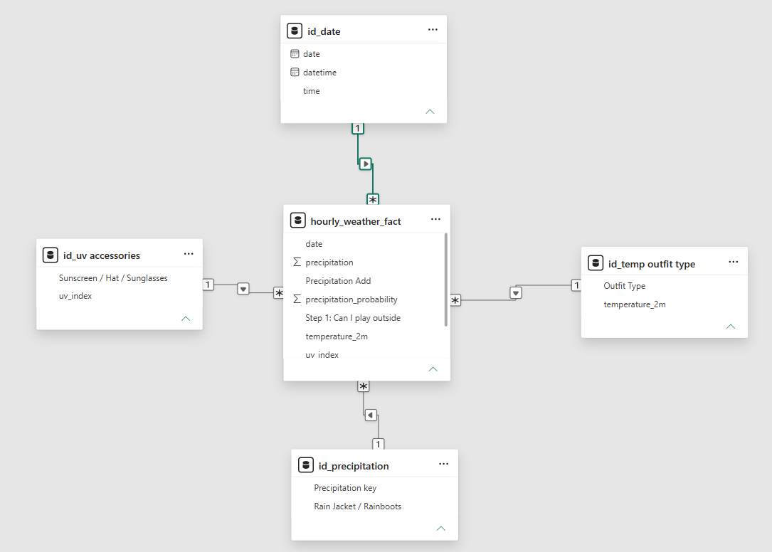
All many-to-one relationships for filtering
- Id_uv accessories (uv_index) to hourly_weather_fact (uv_index)
- Id_date (datetime) to hourly_weather_fact (date)
- Id_temp outfit type (temperature_2m) to hourly_weather_fact (temperature_2m)
- Id_precipitation (Precipitation Key) to hourly_weather_fact (Precipitation Add)

